**Artificial Intelligence**

**Assignment # 4**

**Name: Muhammad Bilal Reg. no: 19-Arid-825**

**Degree: BSCS – 6 Section: B**

**PyKE Already Installed:**

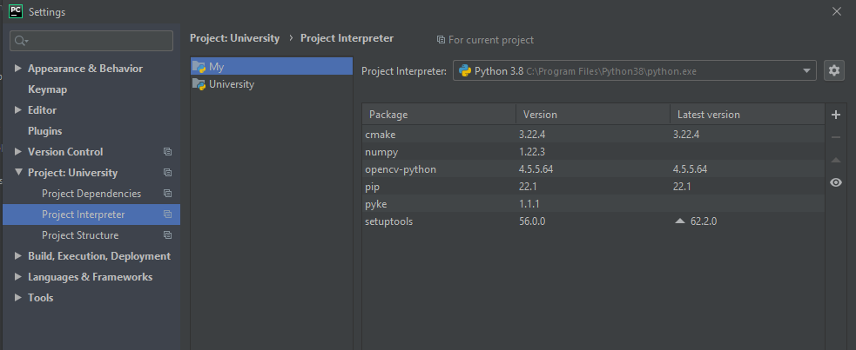

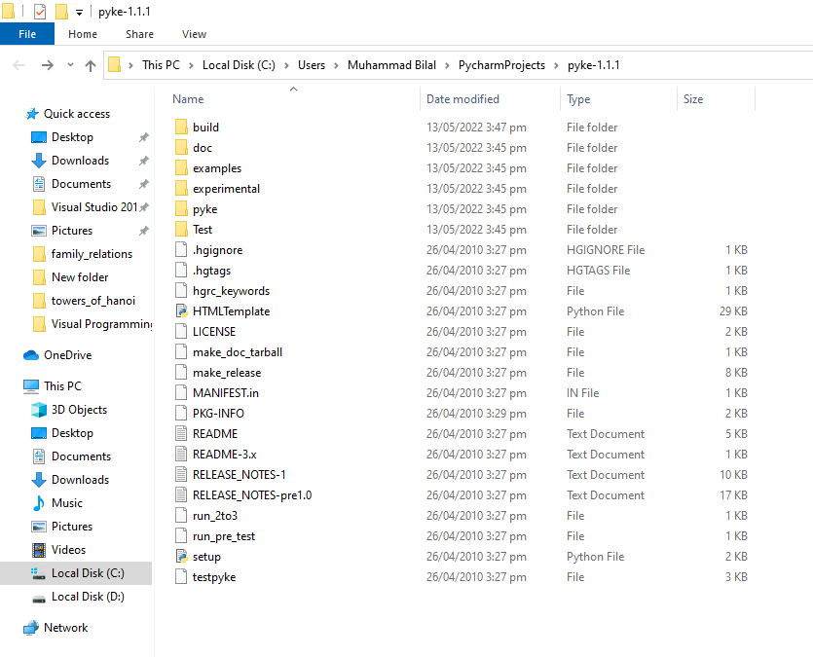

**Example 1:**

**Code:**

import driver

driver.test(2)

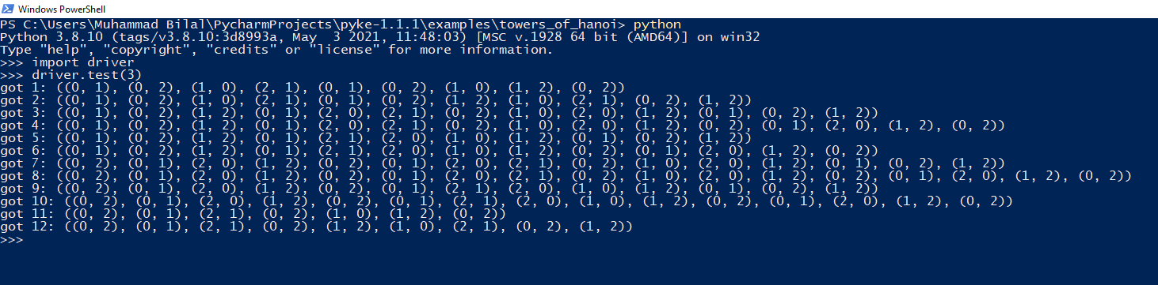

**Example 2:**

**Code:**

import driver

driver.run((('bread',4,9200),

... ('pasta',2,4500),

... ('peanutButter',1,6700),

... ('babyFood',3,6900)),

... 4)

